Library Management System
I. Functional requirements
1. log in / log out
+ The system allows users (such as librarians, staff, or readers) to log in using their account credentials. Once authenticated, users can access the system’s features according to their role
+ The log-out function securely ends the session to protect user information
2. book management
+ This function allows librarians or administrators to manage book information in the system. They can add new books, update book details (such as title, author, category, and availability status), or remove books that are no longer in the library collection
3. reader management
+ The system manages information about readers, including their personal details, contact information, and borrowing history. Librarians can register new readers, update their information, or deactivate accounts when necessary
4. library staff management
+ This function manages data related to library staff, such as names, roles, contact information, and work schedules. Administrators can create, edit, or remove staff accounts and assign permissions according to their responsibilities
5. book borrowing / returning management
+ The system records and tracks all book borrowing and returning transactions. Librarians can check book availability, issue books to readers, record return dates, and calculate fines for overdue books automatically
6. search and statistics
+ The system provides a search function to find books, readers, or borrow records quickly using keywords or filters. It also generates statistical reports, such as the number of borrowed books, most popular titles, or overdue records, to support library management decisions

II. Non-functional requirements
1. Performance
+ The system should respond to user search operations within less than 3 seconds to ensure a smooth user experience and minimize waiting time
2. Security
+ Users must log in before performing any operations. This helps protect sensitive data, prevent unauthorized access, and ensure that each user’s actions are traceable
3. Usability
+ The system should provide a user-friendly interface that is easy to navigate, even for users without technical or IT backgrounds
4. Storage
+ All data must be stored in a reliable database management system such as MySQL or SQLite to ensure data persistence, consistency, and easy retrieval
5. Integrity
+ The system must maintain data integrity by preventing deletion of books that are currently borrowed by any reader

III. Data Flow Diagrams
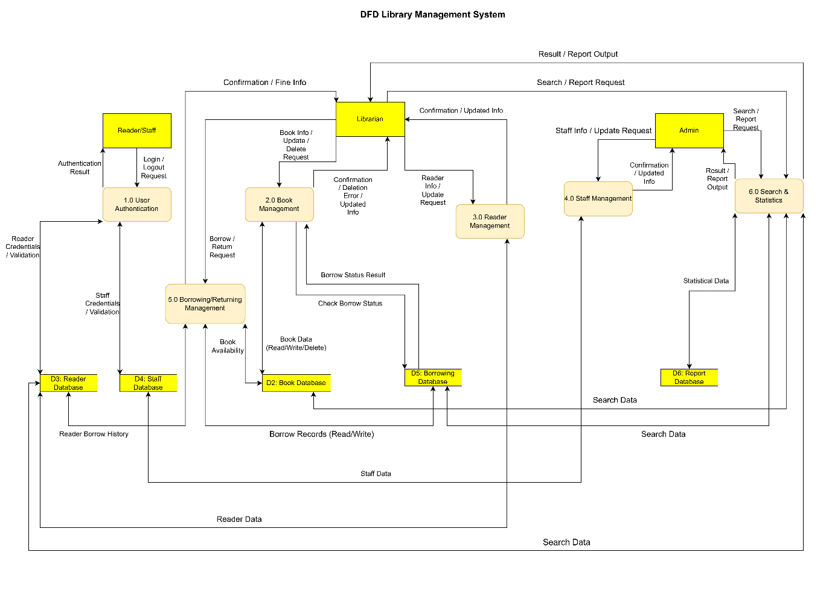

IV. Use Case Diagrams
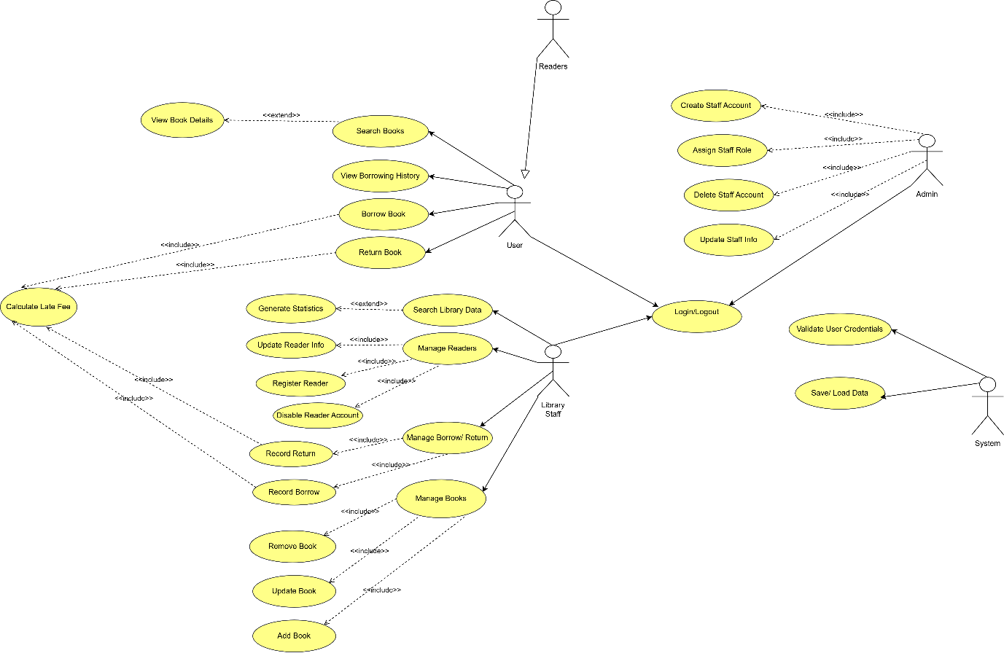
1.1. List of Actors
Stt | Use Case | Description
1 | User | A general actor representing anyone who uses the library system.
2 | Student | A library user who borrows and renews books for study purposes. Inherits all behaviors from User.
3 | Staff | A faculty or university staff member who uses the library services. Inherits all behaviors from User.
4 | Library Staff | A library employee responsible for managing book records and user requests.
5 | Database Manager | The system administrator who manages and maintains the library database.

1.2. List of Use Cases
Stt | Use case | Descripton | Notes (Group)
1 | Login | Allows users (students, staff, or library staff) to log in to the system. | A
2 | Verify Username and Password | Checks the validity of login credentials. | A.1
3 | New User Registration | Enables new users to register for a library account. | B
4 | Fill Up Registration Form | Collects personal details from the user during registration. | B.1
5 | Get Library Card | Issues a library card for a successfully registered user. | B.2
6 | Valid or Invalid | Validates the registration information provided by the user. | B.3
7 | Request New Book | Allows users (students or staff) to request new books. | C
8 | Renew Book | Enables users to renew borrowed books. | D
9 | Verify Eligibility | Checks if the user meets the criteria to renew a book. | D.1
10 | Penalty Details | Displays a user’s penalty and fine information. | E
11 | Card Payment | Pay penalties via card transaction. | E.1
12 | Cash Payment | Pay penalties in cash. | E.2
13 | Wallet Payment | Pay penalties using an e-wallet. | E.3
14 | Manage Book Details | Manages all book-related information. | F
15 | Add Book | Adds new books to the system. | F.1
16 | Update Book | Updates book information. | F.2
17 | Delete Book | Removes books from the system. | F.3
18 | View Book | Views or searches book details. | F.4
19 | Manage Library Database | Maintains and manages the library database. | G

2. Use-case Browse Books
2.1 Summary
This use case allows users to browse the library’s collection of books by category or author. Users can view available books and sort them by title, author, or publication year.
2.2 Main Flow of Events
1. The use case begins when the user selects 'Browse Books'.
2. The system displays a list of book categories.
3. The user selects a category to view the list of books under it.
4. The system shows a list of books in that category, including title, author, and availability.
5. The user can choose to sort or filter the list based on title, author, or publication year.
6. The system updates the display according to the selected sorting criteria.
7. The user may choose to view detailed information about a specific book.
2.3 Alternative Flow
1. None.
2.4 Special Requirements
None.
2.5 System State Before Use Case
None.
2.6 System State After Use Case
None.
2.7 Extension Points
Use-case Request New Book: If the user cannot find a desired book, they may request a new one.
3. Use-case Search Books
3.1 Summary
This use case allows users to search for books by title, author, or keyword.
3.2 Main Flow of Events
1. The use case begins when the user selects the 'Search' option.
2. The system displays a search bar for input.
3. The user enters a title, author name, or keyword and initiates the search.
4. The system searches the database for matching books.
5. The system displays a list of results including title, author, and availability.
6. The user can select a book to view detailed information.
3.3 Alternative Flow
None.
3.4 Special Requirements
None.
3.5 System State Before Use Case
None.
3.6 System State After Use Case
None.
3.7 Extension Points
Use-case Browse Books: The user may switch from search results to browsing categories.
4. Use-case Manage Book Details
4.1 Summary
This use case allows library staff to manage book information, including adding, updating, deleting, and viewing books.
4.2 Main Flow of Events
1. The use case begins when library staff selects 'Manage Book Details'.
2. The system displays options: Add Book, Update Book, Delete Book, View Book.
3. If 'Add Book' is selected, staff enters book information and submits.
4. The system validates and saves the new book record.
5. If 'Update Book' is selected, staff selects a book and edits details.
6. The system updates the record and confirms success.
7. If 'Delete Book' is selected, the system asks for confirmation, then removes the book from the catalog.
4.3 Alternative Flow
None.
4.4 Special Requirements
None.
4.5 System State Before Use Case
Staff must be logged in.
4.6 System State After Use Case
Book data is added, modified, or removed.
4.7 Extension Points
None.
5. Use-case Login
5.1 Summary
This use case allows users and staff to log in to the library system using their credentials.
5.2 Main Flow of Events
1. The use case begins when the user selects the 'Login' option.
2. The system prompts for username and password.
3. The user enters credentials and submits.
4. The system verifies the credentials.
5. If valid, the user gains access to the system.
6. If invalid, an error message is displayed.
5.3 Alternative Flow
1. If the password is forgotten, the user can use the Reset Password use case.
5.4 Special Requirements
None.
5.5 System State Before Use Case
User not logged in.
5.6 System State After Use Case
User is logged in.
5.7 Extension Points
Reset Password.
6. Use-case Register New User
6.1 Summary
This use case allows new users to create an account in the library system.
6.2 Main Flow of Events
1. The use case begins when the user selects 'Register'.
2. The system displays a registration form for the user to fill in details such as name, date of birth, email, and password.
3. The user submits the form.
4. The system validates the input information.
5. If valid, the system creates a new account and issues a library card.
6. If invalid, the system displays error messages for correction.
6.3 Alternative Flow
1. If the email is already registered, the system shows an error.
6.4 Special Requirements
Passwords must be encrypted before storing.
6.5 System State Before Use Case
None.
6.6 System State After Use Case
A new user account is created.
6.7 Extension Points
None.
7. Use-case Update User Profile
7.1 Summary
This use case allows logged-in users to update their personal information.
7.2 Main Flow of Events
1. The use case begins when the user selects 'Edit Profile'.
2. The system displays current user information.
3. The user modifies details such as address or contact number.
4. The user saves the changes.
5. The system validates and updates the user information.
7.3 Alternative Flow
1. If the user cancels, no changes are saved.
7.4 Special Requirements
None.
7.5 System State Before Use Case
User must be logged in.
7.6 System State After Use Case
User data updated.
7.7 Extension Points
None.

V. Class Diagrams
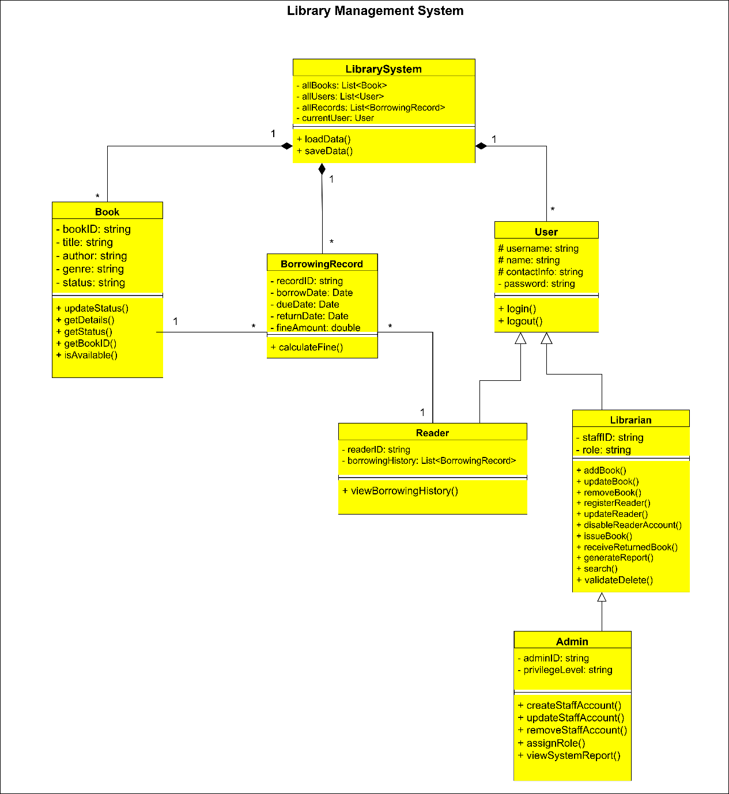
VI. User interface design description
The Library Management System is a console-based application, meaning all interactions between users and the system are performed through text displayed on the screen. The interface is designed to be simple, clear, and easy to navigate using numeric options and keyboard input.
When the program starts, the system displays the Main Menu with two options: “Log in” and “Exit”. The user can select an option by typing the corresponding number. If the user chooses to exit, the system will close immediately.
When the user chooses to log in, the Login Screen appears, asking for a username and password. If the credentials are correct, the user is redirected to the Librarian Main Menu. Otherwise, the system will display an error message and allow the user to try again.
After logging in successfully, the Librarian Main Menu is shown. This menu provides options for managing different parts of the library system, including book management, reader management, borrowing and returning management, search and statistics, and logging out. The user can select any option to access its corresponding submenu.
In the Book Management section, librarians can add new books, update existing book information, delete books, or view the list of all books. Each action requires the user to enter relevant details such as book ID, title, author, category, and availability status. After each operation, the system displays a confirmation message (for example, “Book added successfully”).
The Reader Management section allows the librarian to register new readers, update reader details, delete reader profiles, or view a list of all registered readers. The system will confirm when each operation is completed successfully.
The Borrow and Return Management section is used to handle all book borrowing and returning activities. The librarian can record new borrow transactions by entering the reader ID and book ID, or process book returns by entering the borrow record ID. The system automatically checks the availability of the book and calculates overdue fines if necessary.
The Search and Statistics section provides options to search for books or readers using keywords and to view statistical information such as the most borrowed books and overdue books. The results are displayed in a clear list format for easy reading.
When the user chooses to log out, the system will ask for confirmation and then return to the main menu. If the user chooses to exit from the main menu, the system displays a farewell message and closes the program.
Overall, the console interface is text-based, menu-driven, and designed for simplicity. It guides users step by step through clear prompts, ensuring that even users without technical experience can use the system effectively.
VII. Design the database
